Key Term Definition | Picture |  | Key Term Definition | Picture
Gene |  |  | Allele
Dominant |  |  | Recessive
Genotype |  |  | Phenotype
Homozygous |  |  | Heterozygous
Heredity Vocabulary Squares
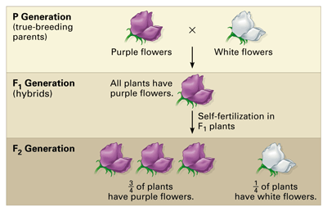
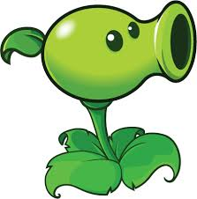
Gregor Mendel’s Pea Plant Experiment

P Generation:

F1 Generation:

F2 Generation:

Green True Breeding Pea Shooter
BB

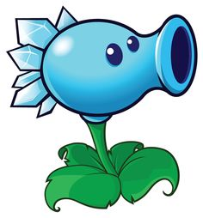
Phenotypic Ratio:

Genotypic Ratio:
Green Hybrid Pea Shooter
Bb
Green Hybrid Pea Shooter
Bb
True-breeding:

Hybrid:

P generation

F generations:

Law of dominance:

Law of segregation:

How did Gregor Mendel’s experiment
Prove the law of segregation?
Blue True Breeding Pea Shooter
bb

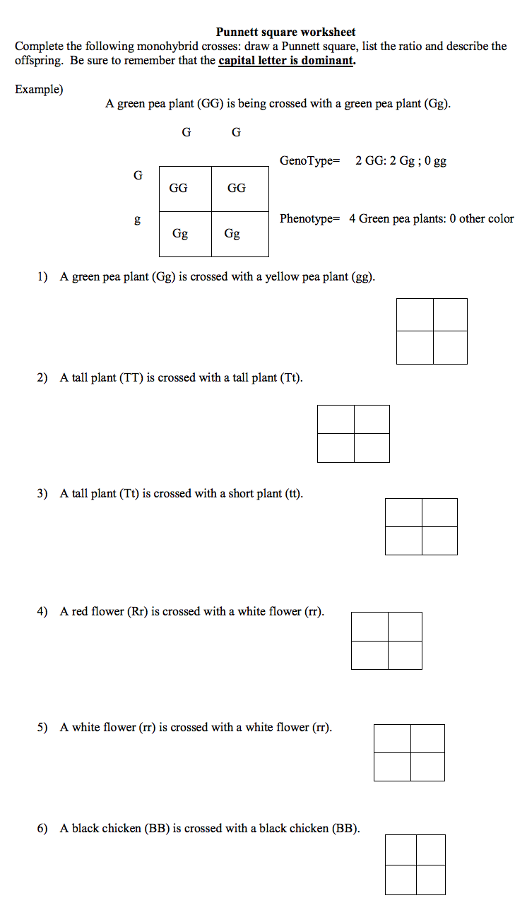

Punnett square problems continued
Complete the following problems. List the parent genotypes, draw and fill in a Punnett square, and then list the offspring genotypes and phenotypes.

- A homozygous dominant brown mouse is crossed with a heterozygous brown mouse (tan is the recessive color).

- A heterozygous tall plant is crossed with a homozygous short plant.

3. Albinism or the lack of skin pigment is recessive to having skin color. Alpha is albino is crossed with Beta who is heterozygous for skin pigment.

4. Mohawks are dominant to baldness. Mr. Brass has a Mohawk and Mrs. Brass is bald. They have three children, Diamond, Copper, and Iron. Diamond and Copper have Mohawks but Iron does not have a Mohawk. Can Mr. Brass be the father of Iron? Make a Punnett Square AND WRITE AN ARGUMENT why or why not Iron is Mr. Brasses child

Dihybrid Crosses
Example:
A tall green pea plant (TTGG) is crossed with a tall white pea plant (Ttgg).

TT or Tt = tall tt = short GG or Gg = green gg = white

Tall Green Plant:

1
2

T T G G
4
3
Tall White Plant:
TG TG TG TG
2
1
Tg
T t g g
tg
tg
Tg
4
3
TTGg | TTGg | TTGg | TTGg
TTGg | TTGg | TTGg | TTGg
TtGg | TtGg | TtGg | TtGg
TtGg | TtGg | TtGg | TtGg

- A tall green pea plant (TtGg) is crossed with a Short white pea plant (ttgg).

___________ X ___________

____ Tall/Green : ____ Tall/white : ____ short/Green : ____ short/ white
- A Homozygous tall, green flowered plant is crossed with a Homozygous short white flowered plant.

___________ X ___________

____ Tall/green : ____Tall/White : ____ Short/green: ____ Short/White

- Two Heterozygous Tall, Green pea plants are crossed.

___________ X ___________

____ Tall/Green : ____ Tall/White : ____ Short/Green : ____ Short/ White

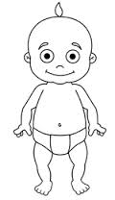
Name_____________________ Create a Baby Lab
Introduction:
One of the defining characteristics of life is heredity or the passing down of traits from parent to offspring.
Heredity occurs when two (or sometimes more) parents combine their D.N.A. during meiosis to form offspring.
If you know the alleles of each parent you can predict which allele their child will inherit.

Genetic Factors | Physical Factors
A gene is a segment of D.N.A. that codes for protein.  The set of alleles a gene has is called a genotype  Genotypes are represented by letters  Ex. AA, Aa, and aa  Dominant alleles are represented by capital letters  Recessive alleles are represented by lower case letters | A trait is a physical characteristic  The physical appearance of a trait is called a phenotype  Phenotypes are represented as descriptions of a trait  Ex. Blue Eyes, Tall vs. Short, and Bald vs Hairy
Lets say dark hair is dominant (D) and light hair is recessive (d).
For a person with dark hair we would say…  A person with genotype____ or ___ as the phenotype of_______. | For a person with light hair we would say…  A person with a genotype ____ has the phenotype of __________.

Procedure: In this lab you will work with a partner to create a fictional child.

- With your partner, use table 2 to determine what alleles each of you have for a listed trait. Record your results on table 1.

- After discovering your alleles, combine them to determine the genotype and phenotype of your fictional child. The combining of two alleles (2 haploid cells) into one genotype (1 diploid cell) occurs during meiosis.

- Draw your fictional baby on the last page with the characteristics determined by you and your partners combined genotypes and phenotypes.
Table 1: Parent and Child Alleles
Mom's Name: ________________ | Dad's Name _________________ | Baby's Name: ________________

Trait | Dominant | Recessive | Allele from Mom | Allele from Dad | Genotype | Phenotype
Freckles | F | f | _____________ | _____________ | _____________ | _____________
Cheek Dimples | D | d | _____________ | _____________ | _____________ | _____________
Lip Thickness | T | t | _____________ | _____________ | _____________ | _____________
Eye Brows | B | b | _____________ | _____________ | _____________ | _____________
Eyelashes | L | l | _____________ | _____________ | _____________ | _____________
Ear Lobes | F | f | _____________ | _____________ | _____________ | _____________
Widow's Peak | W | w | _____________ | _____________ | _____________ | _____________
Hair Curliness | C | c | _____________ | _____________ | _____________ | _____________
Mouth Size | M | m | _____________ | _____________ | _____________ | _____________
Nose Size | P | p | _____________ | _____________ | _____________ | _____________
Skin Tone | G | g | _____________ | _____________ | _____________ | _____________
Eye Color | E | e | _____________ | _____________ | _____________ | _____________
Hair Color  To find the gender of your baby:  Females ALWAYS give an ‘X’ allele to their child because the female genotype is XX  Female partner should write ‘X’  A male can give either an ‘X’ or ‘Y’ allele to their child because the male genotype is XY  Male partner must flip a coin to determine the allele. For Heads, write the ‘X’ allele, for tails, write the ‘Y’ allele. | H | h | ____________ | _____________ | _____________ | _____________
Gender | X | Y | _____________ | _____________ | _  ____________ | _____________

NOTE: Hair and eye color ARE NOT monogenic traits like shown above. They are actually polygenic. This is a gross oversimplification.

Table 2: Genotype/Phenotype Key

Trait | Genotype/Phenotype  (Homozygous Dominant) | Genotype/Phenotype  (Heterozygous) | Genotype/Phenotype  (Homozygous Recessive)
Gender |   XX  Girl | 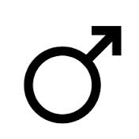  XY  Boy | YY  NOT POSSIBLE
Freckles | 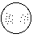  FF  Present | Ff  Present | 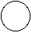  ff  Absent
Cheek Dimples | DD  Present | Dd  Present | dd  Absent
Lip Thickness | 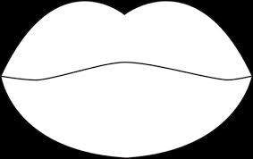  TT  Thick | Tt  Thick | 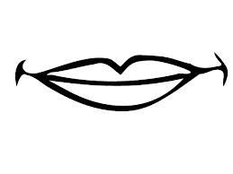  tt  Thin
Eye Brows | 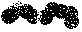  BB  Bushy | Bb  Bushy | bb  Fine
Eyelashes | LL  Long | Ll  Long | ll  Short
Ear Lobes | 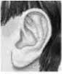  FF  Free | Ff  Free | 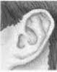  ff  Attached
Widow's Peak | WW  Present | Ww  Present | ww  Absent
Hair Curliness | 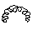  CC  Curly | 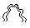  Cc  Wavy | cc  Straight
Mouth Size | 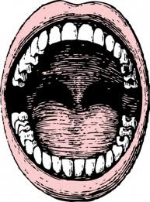  MM  Large | 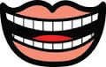  Mm  Medium | 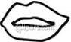  mm  Small
Nose Size | PP  Large | Pp  Medium | pp  Small
Skin Tone |   GG  Dark |   Gg  Medium | 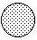  gg  light
Eye Color | EE  Brown | Ee  Hazel | ee  Blue
Hair Color | HH  Black | Hh  Brown | hh  Blonde
Draw your baby
Use the allele chart to see which traits your baby inherited from each parent

The proud parents _______________ and ________________ present baby________________

